Parental Control Setup Manual
Lenovo TB-7304i

1. Open the settings screen
Unblock the screen and open the notification menu by swiping from the top border of the screen
to bottom border, then tap on gear icon.

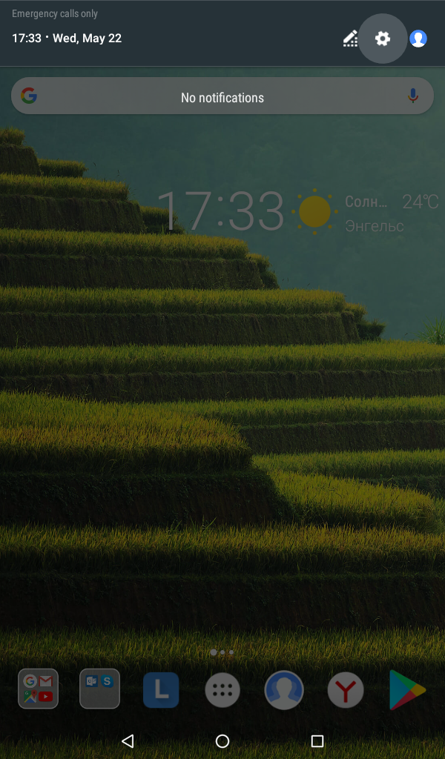
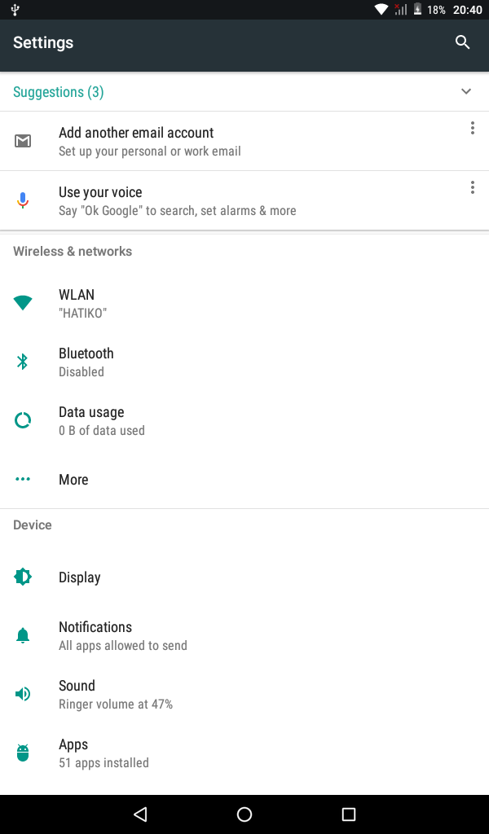

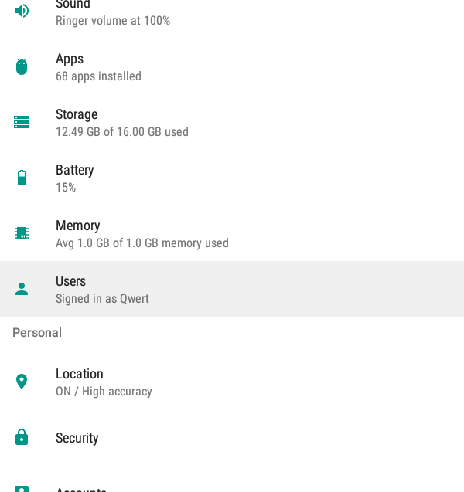
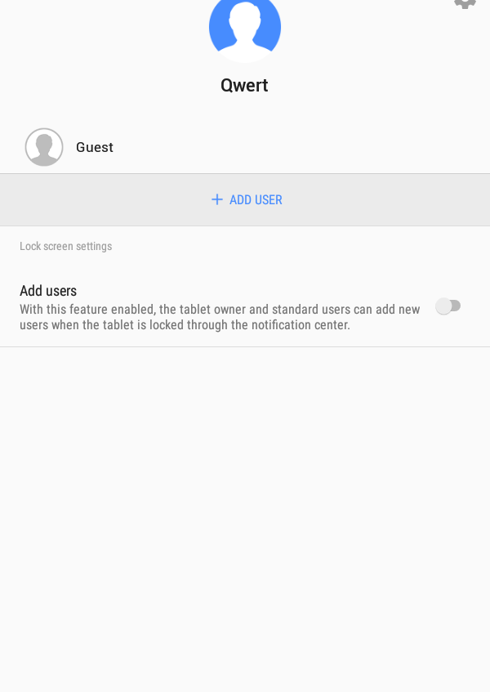
2. Select «Users» submenu
3. Create new user of the type « Child user»
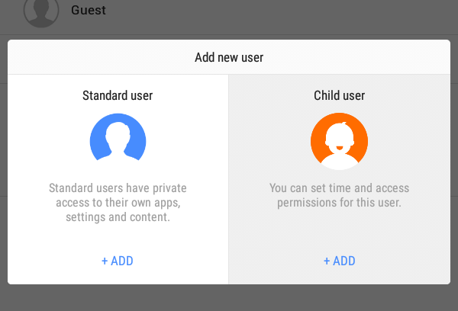
Tap on « + ADD USER» button and select the necessary type.

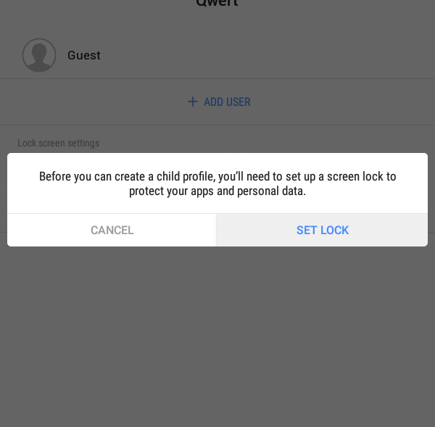
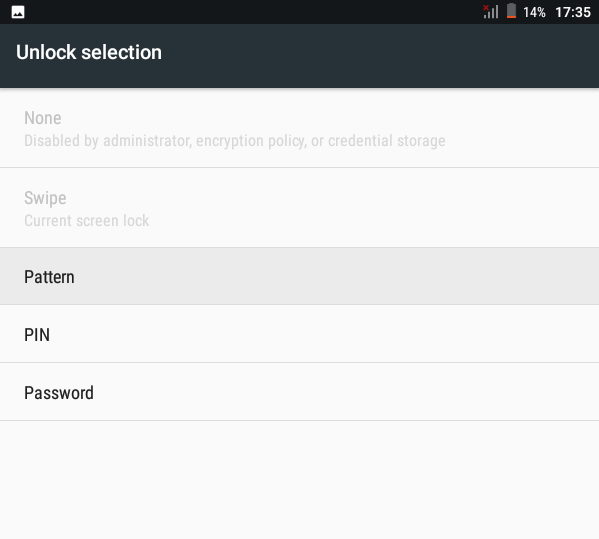
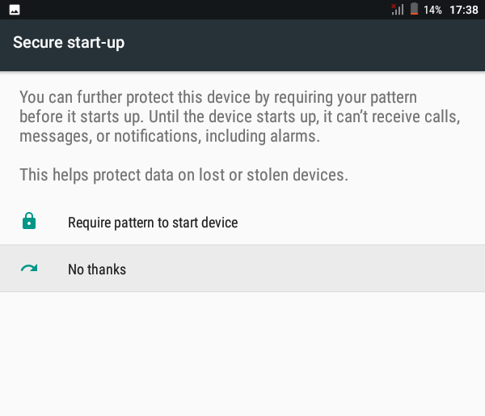
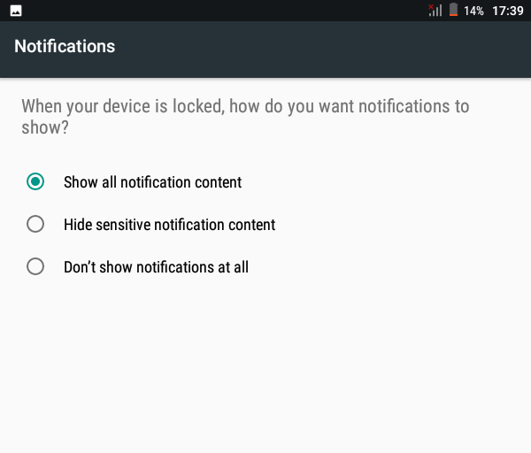
In case there is no screen blocking set up you will be prompted to configure it. Perform the
actions like it is shown on the pictures below to do it.
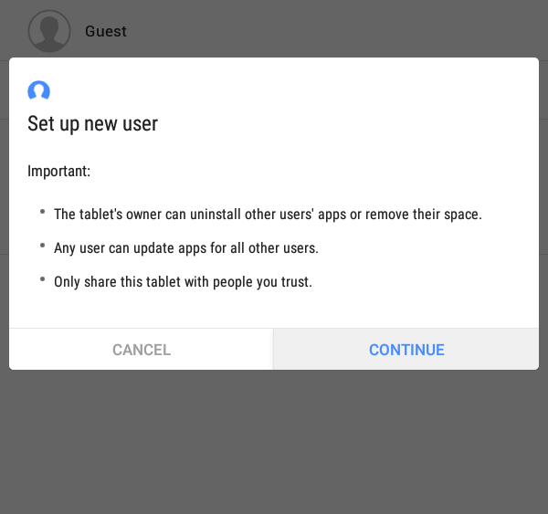
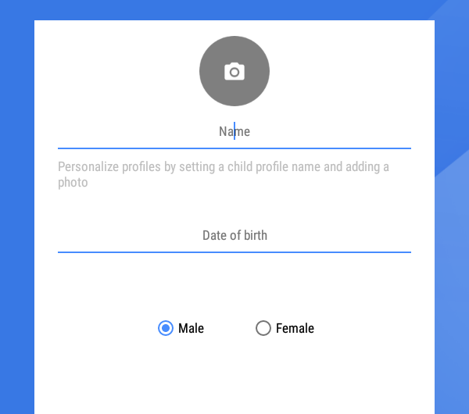
4. Press continue button «CONTINUE». You will be prompted to input the name, birth date and gender of a child. Leave the fields blank and press «NEXT».

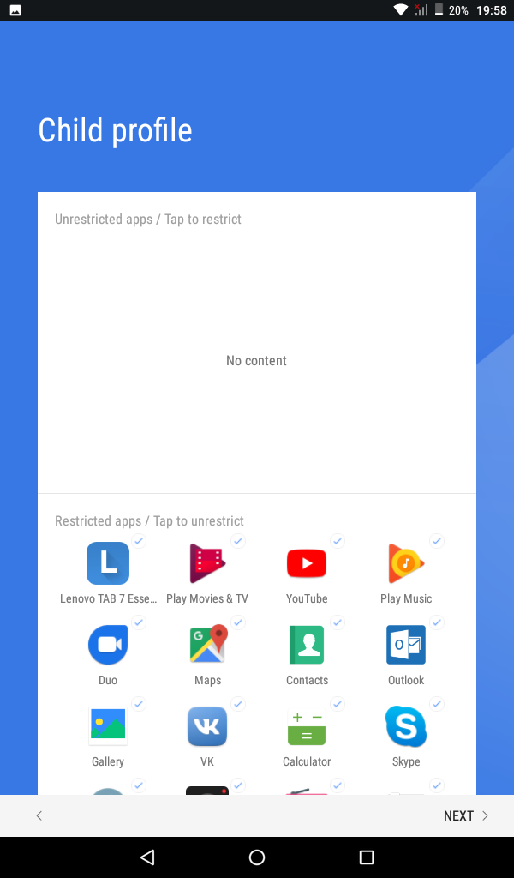
5. You will be prompted add applications the child will be allowed to run.
Don“t add anything. Press «NEXT».
5. Enabling wikipedia.org website access
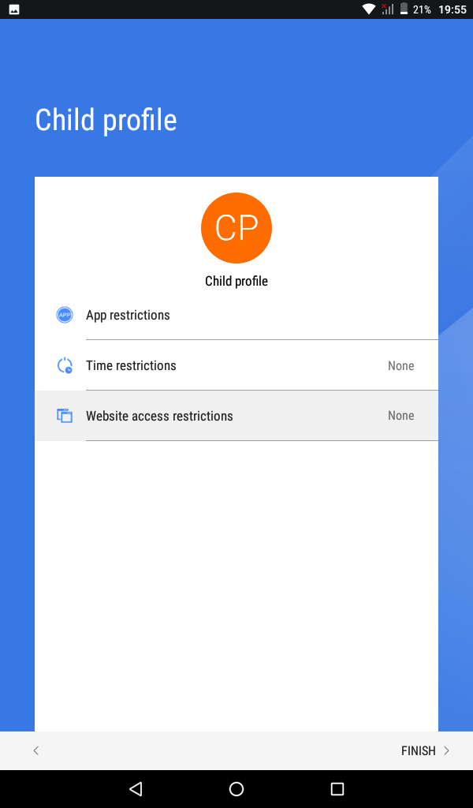
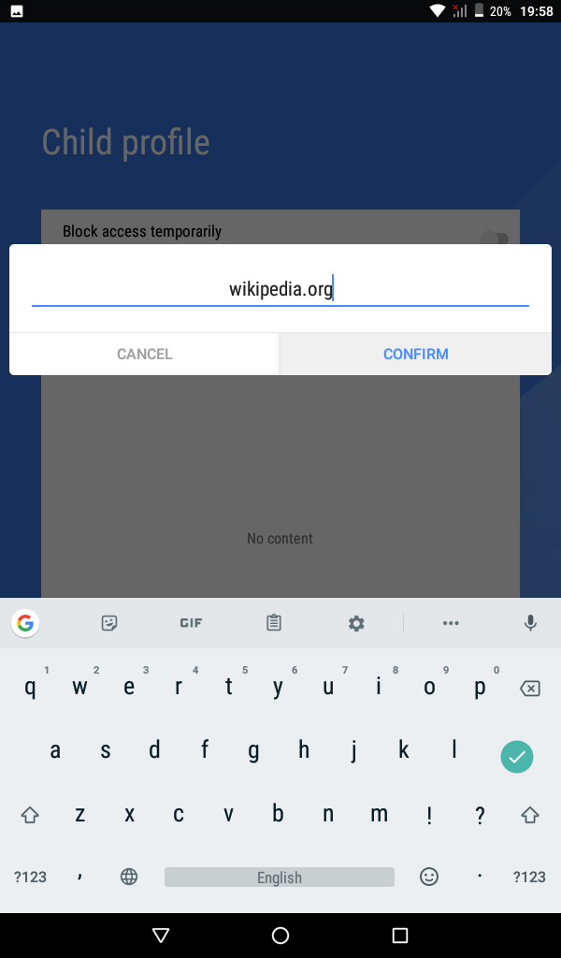
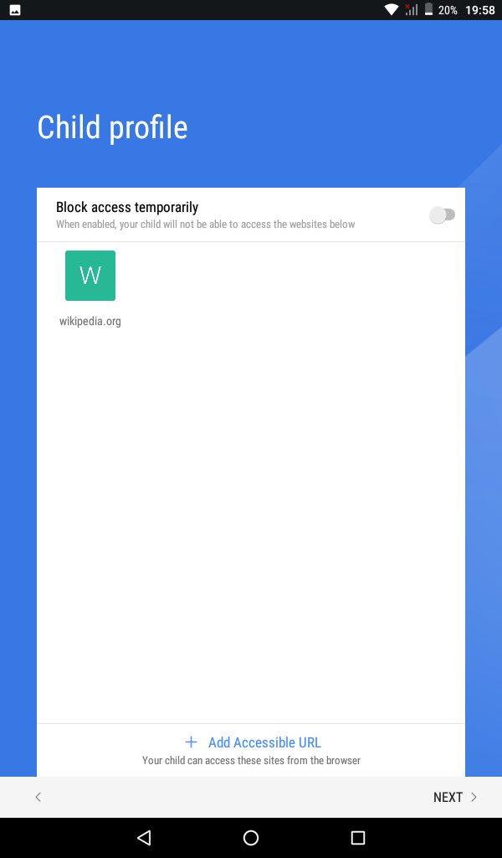
Choose «Website access restrictions» element. Input wikipedia.org in the text filed. Press «CONFIRM» and then «NEXT» several times.

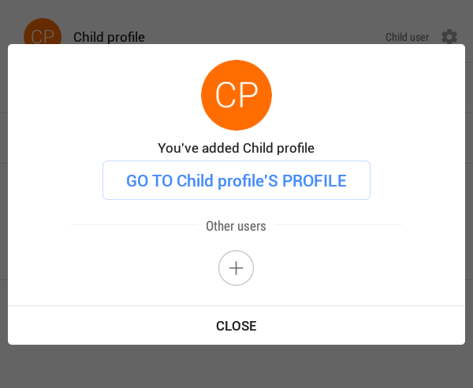
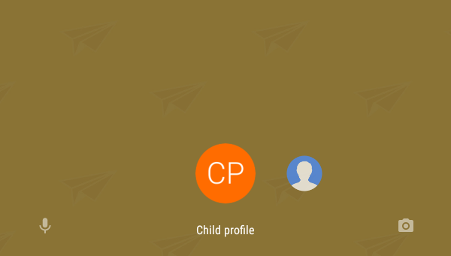
6. The profile setup is finished and you will be prompted to switch to child profile. In order to return to administrators profile you will need to swipe on profile icon shown on blocking screen.

